**CSA1518-CLOUD COMPUTING**

V.Mrudula

192011395

**EXPT 14**: Demonstrate Infrastructure as a Service (IaaS) by establishing the remote connection, launch the created VM image and run in your desktop.

IMPLEMENTATION:

STEP 1:SELECT VIRTUAL MACHINE

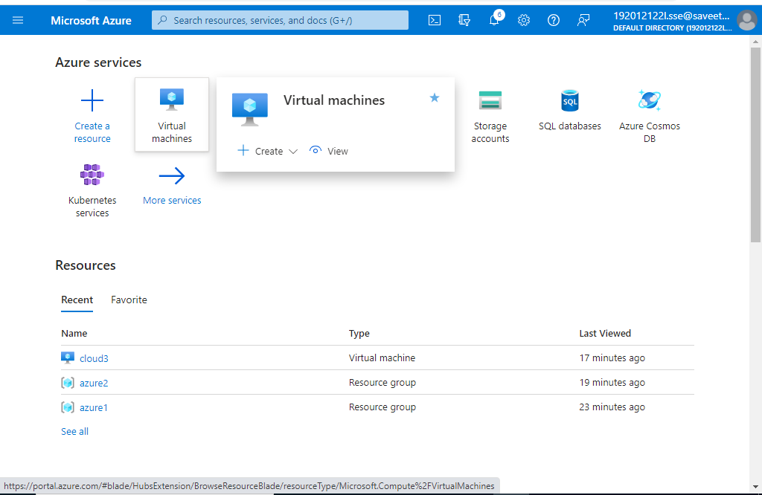

STEP 2:CLICK ON CREATE

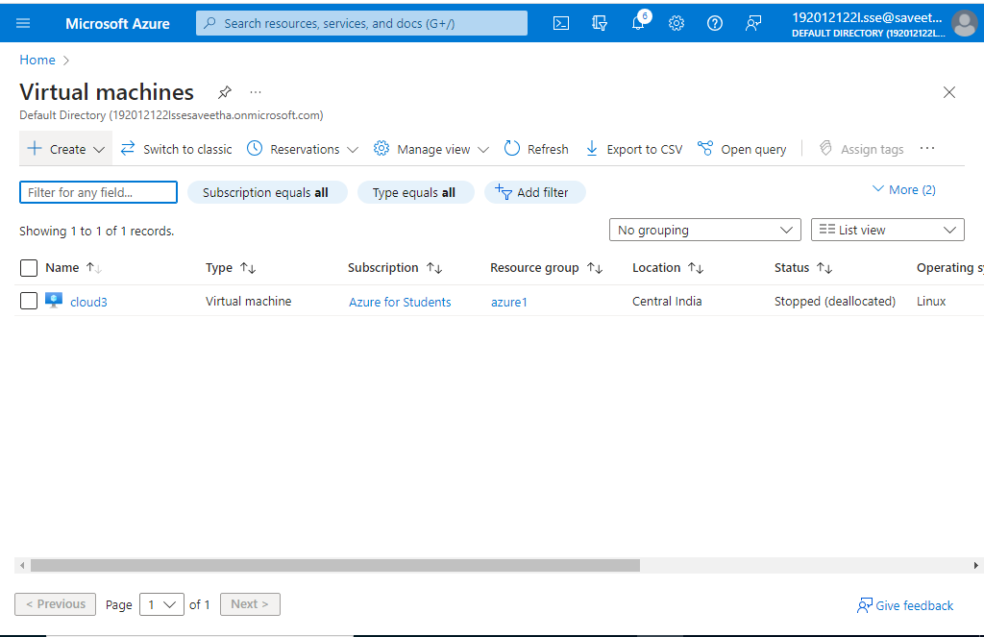

STEP 3:SELECT AZURE VIRTUAL MACHINE

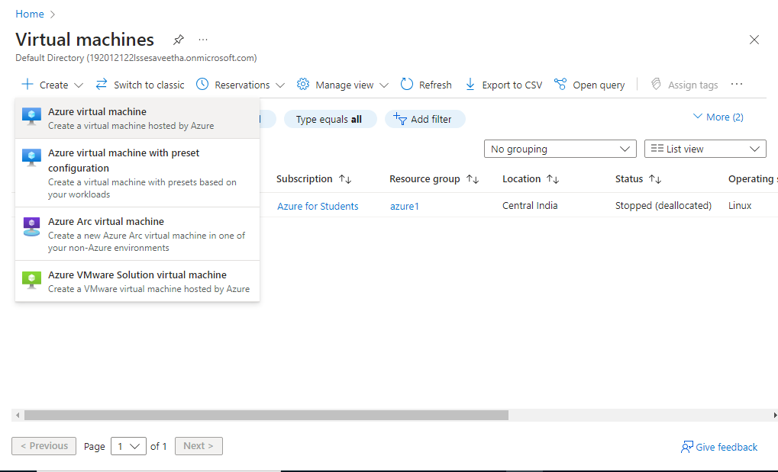

STEP 4:FILL THE DETAILS IN MANDATORY COLUMNS

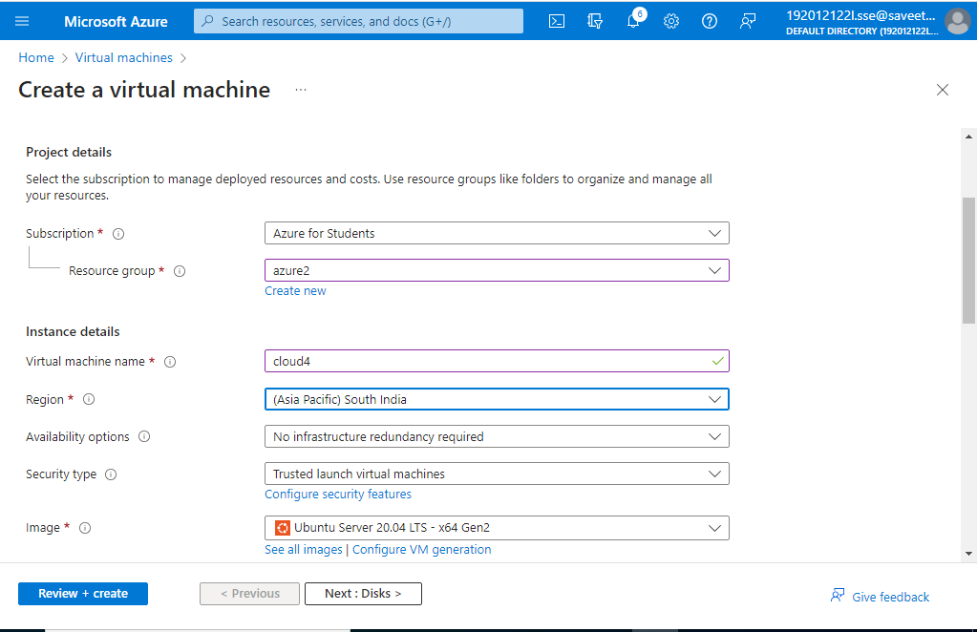

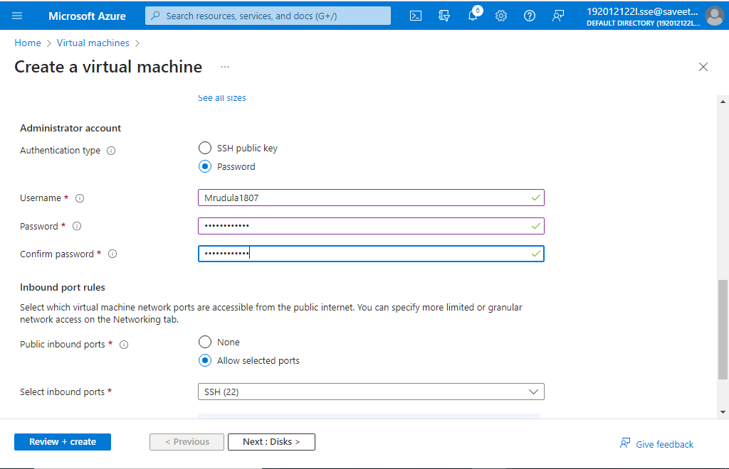

STEP 5:CLICK ON NETWORKING

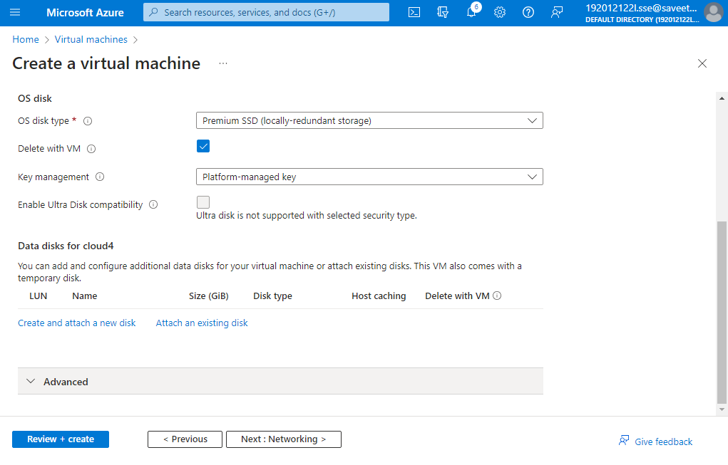

CREATE DISK

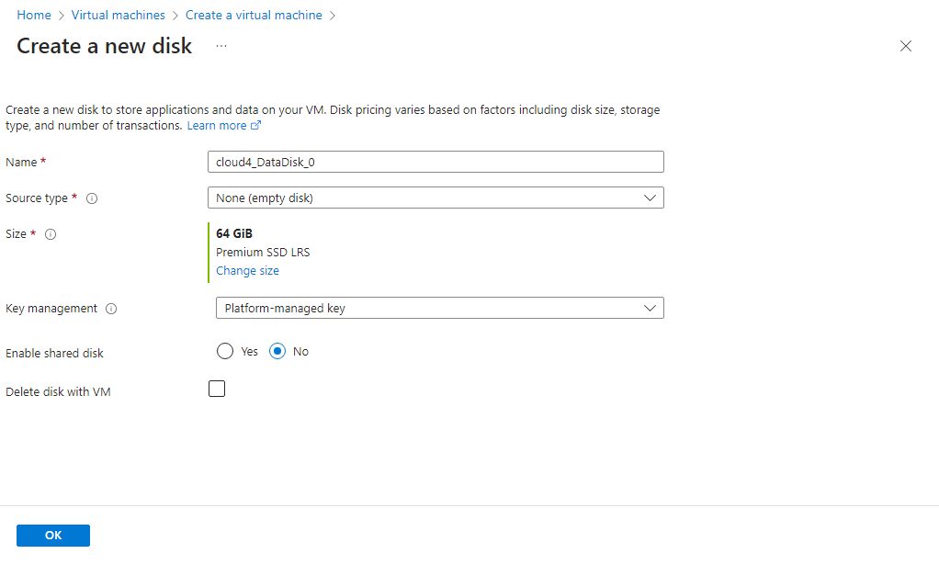

STEP 6:CLICK NEXT: MANAGEMENT

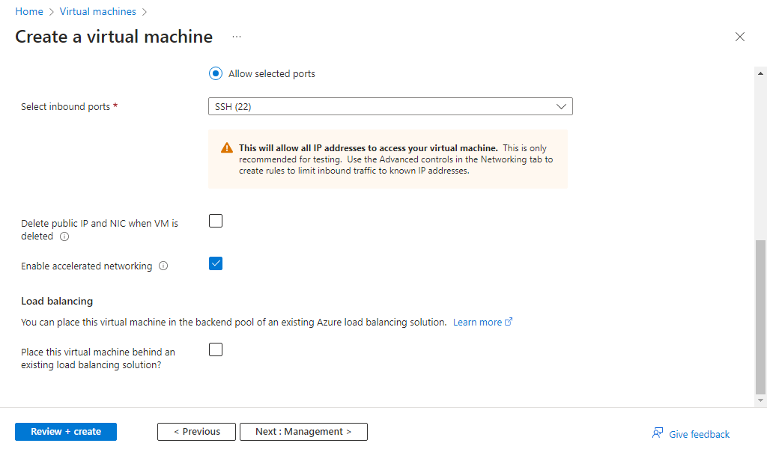

STEP 7:CLICK NEXT:MONITORING

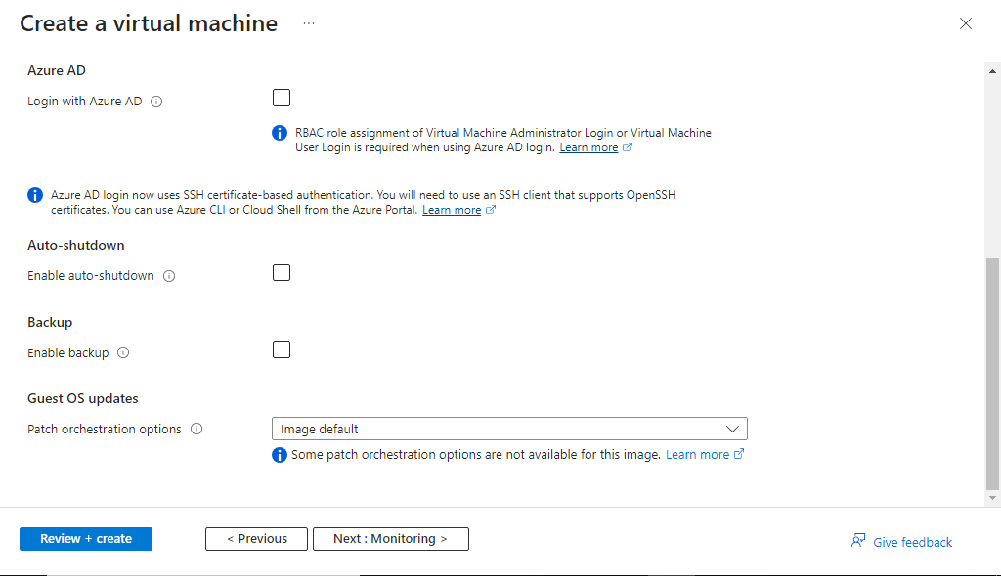

CLICK ON ADVANCED

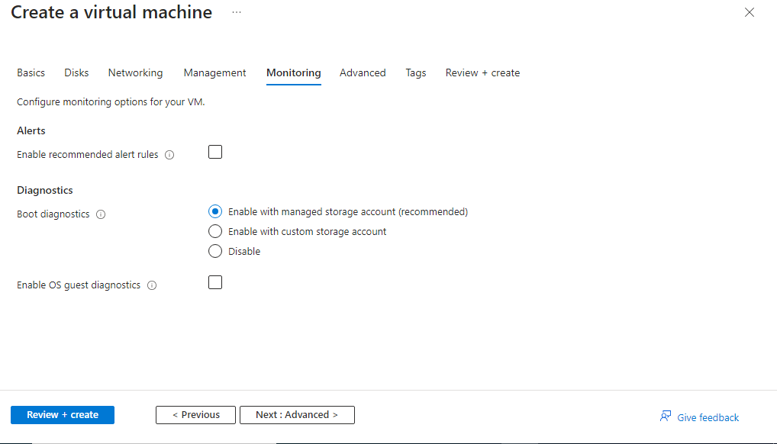

CLICK ON TAGS

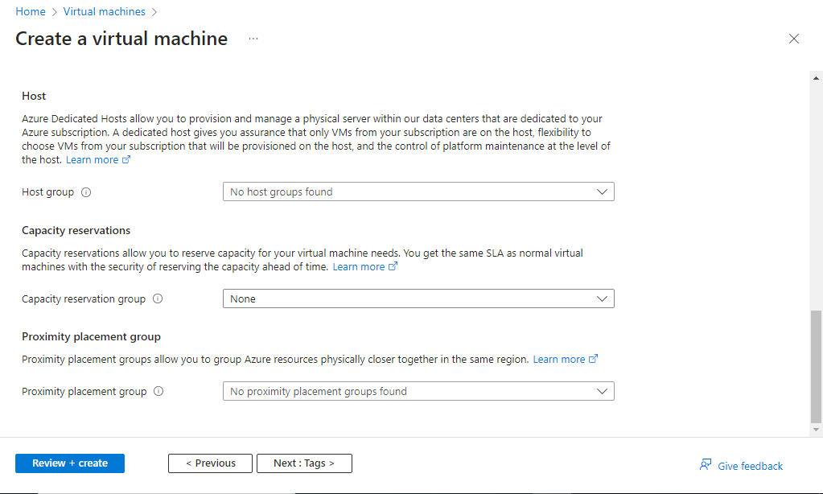

STEP 8:ASSIGN NAME AND VALUE

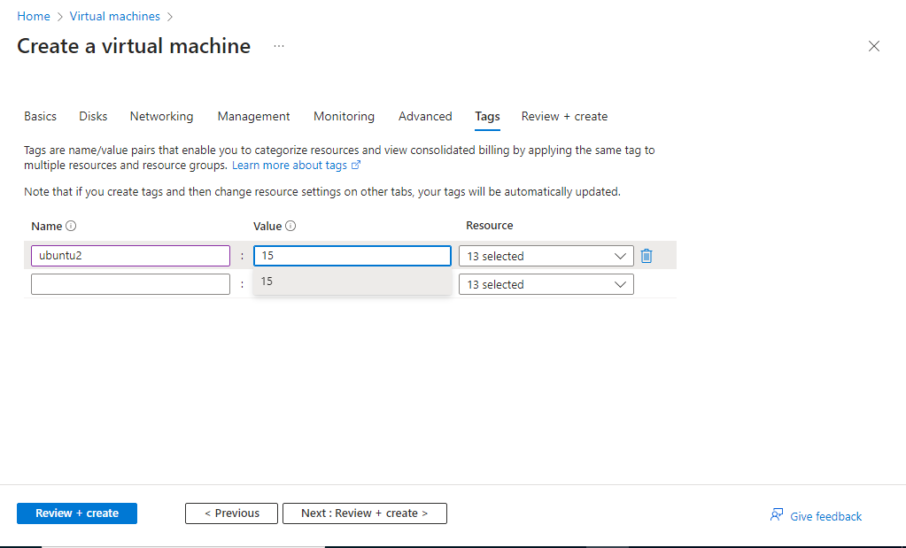

STEP 9:VALIDATION IS PASSED.CLICK ON CREATE

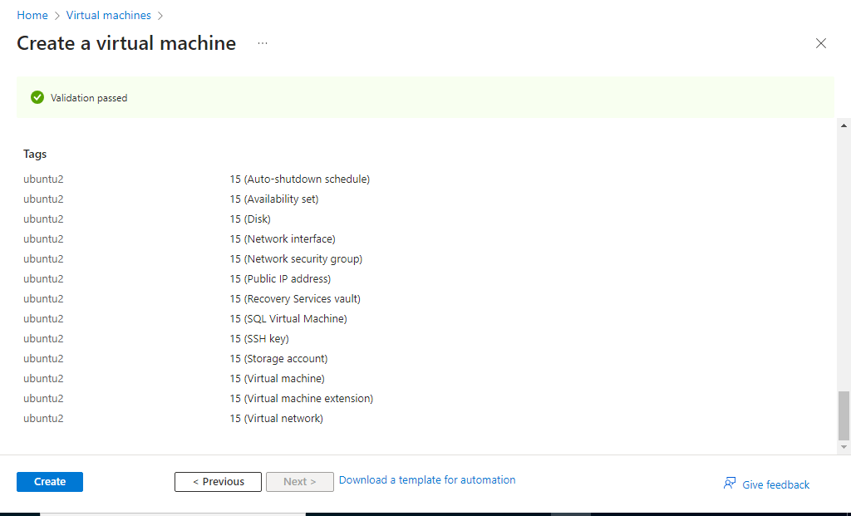

STEP 10:DEPLOYMENT IS COMPLETED

OUTPUT

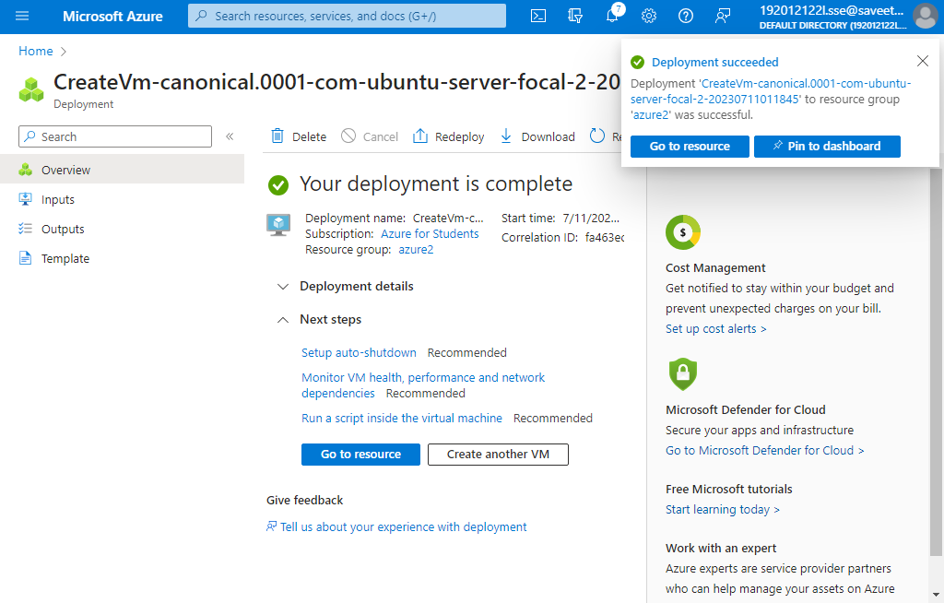

STEP11: 